PAINFUL TOTAL KNEE REPLACEMENT ASSESSMENT 2009
History
………………………………………………………………………………………………………………………………………………………………………
PATIENT LABEL: Name:
Age:

Which knee is troubling you? RIGHT LEFT Date of Consultation:…………

When was your operation? Was your knee fine initially? _____________________

How long has your knee been bothering you? ______________________________________________________

Is your pain worse at Rest (sleep)……. Or… when you start walking……..Or… after walking for a while…….

Have you injured this knee or had any complications after the operation (infection, discharge or redness) _________
_____________________________________________________________________________________________

What is the main problem you have with your knee? e.g. pain, stiffness, instability: _______________________ _
_____________________________________________________________________________________________

What treatment have you had for your knee problem? _______________________________________________

Does the knee problem stop you from doing anything? e.g. walking, sleeping, stair climbing ________________
____________________________________________________________________________________________

How far can you walk? ________Mile ______Yards. Does the knee pain affect your sleep? __________________

What health problems do you have? e.g. Diabetes, Rheumatoid arthritis _________________________________

Do you smoke? ___________________ . How much alcohol do you drink? __________________________

Amount of pain experienced in the past week

A. How much pain do you have? | None  ! | Mild  ! | Mod  ! | Severe  ! | Unbearable  !

Stiffness is a sensation of restriction or slowness in the ease of which you move your knee

B. How severe is your stiffness after first waking in the morning?  How severe is your stiffness after sitting, lying or resting during  the day | None  !  ! | Mild  !  ! | Mod  !  ! | Severe  !  ! | Unbearable  !  !

C. What degree of difficulty do you have with  1. Down stairs  2. Up stairs  3. Rising from sitting  4. Bending to the floor  5. Getting in/out of car  6. Putting on/off socks  7. Getting in/out of bath  8. Heavy domestic duties | None  !  !  !  !  !  !  !  ! | Mild  !  !  !  !  !  !  !  ! | Mod  !  !  !  !  !  !  !  ! | Severe  !  !  !  !  !  !  !  ! | Unbearable  !  !  !  !  !  !  !  !
Oxford Knee Score
(Please tick the most appropriate option in each box)

1. How would you describe the pain you have in your knee? | 7. Could you kneel down and get up again afterwards
□None 1 | □Yes easily 1
□Very Mild 2 | □With little difficulty 2
□Mild 3 | □With moderate difficulty 3
□Moderate 4 | □With extreme difficulty 4
□Severe 5 | □No, impossible 5
2. Have you had any trouble washing and drying yourself (all over) because of your knee? | 8. Are you troubled by pain in your knee at night in bed?
□No trouble at all 1 | □Not at all 1
□Very little trouble 2 | □Only one or two nights 2
□Moderate trouble 3 | □Some nights 3
□Extreme difficulty 4 | □Most nights 4
□Impossible to do 5 | □Every night 5
3. Have you had any trouble getting in and out of a car / using public transport because of your knee? (with or without a stick) | 9. How much has pain from your knee interfered with your usual work? (including housework)
□No trouble at all 1 | □Not at all 1
□Very little trouble 2 | □A little bit 2
□Moderate trouble 3 | □Moderately 3
□Extreme difficulty 4 | □Greatly 4
□Impossible to do 5 | □Totally 5
4. For how long are you able to walk before the pain in your knee becomes severe (with or without a stick) | 10. Have you felt that your knee might “give way” or suddenly let you down
□I have no pain walking for more than an hour 1 | □Rarely / Never 1
□16 – 60 minutes 2 | □Sometimes or just at first 2
□5 – 15 minutes 3 | □Often, not at first 3
□Around the house only 4 | □Most of the time 4
□I cannot walk at all, because of the pain 5 | □All of the time 5
5. After a meal (sat at a table) how painful has it been for you to stand up from a chair because of your knee? | 11. Could you do household shopping on your own?
□ Not at all painful 1 | □ Yes easily 1
□ Slightly painful 2 | □ With little difficulty 2
□ Moderately painful 3 | □ With moderate difficulty 3
□ Very painful 4 | □ With extreme difficulty 4
□ Unbearable 5 | □ No Impossible 5
6. Have you been limping when walking, because of the pain in your knee | 12. Could you walk down a flight of stairs?
□Rarely / never 1 | □Yes easily 1
□Sometimes or just at first 2 | □With little difficulty 2
□Often, not just at first 3 | □With moderate difficulty 3
□Most of the time 4 | □With extreme difficulty 4
□All of the time 5 | □No impossible 5
Total /60

Kujala Knee Score

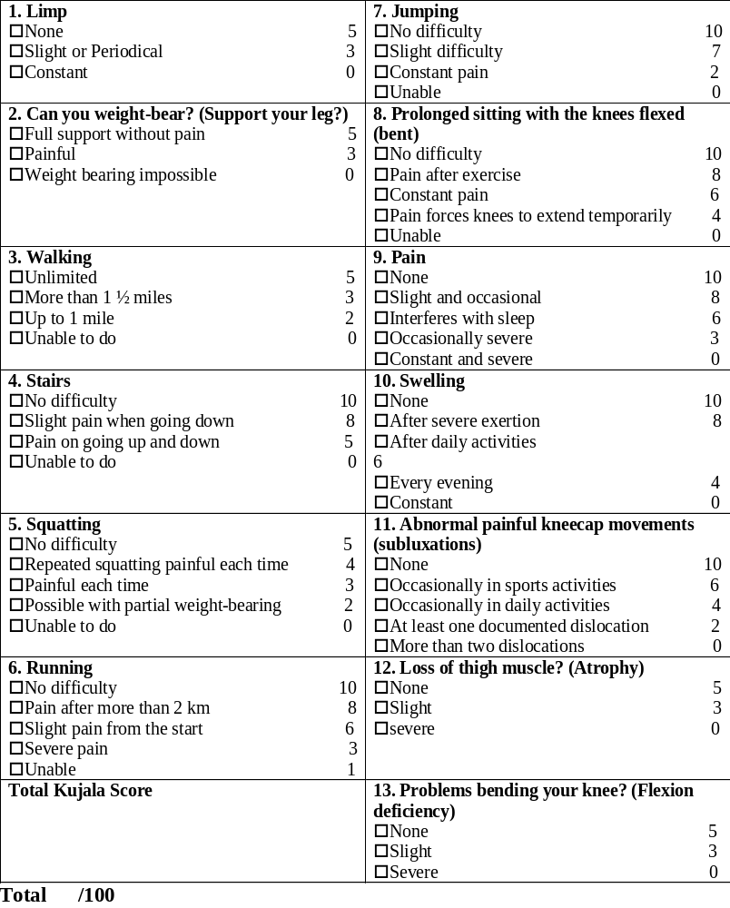

CLINICAL EXAMINATIONS

INDEX SIDE: | [ ] LEFT | [ ] RIGHT
LIMP: | [ ] NO | [ ] YES
WALKING AID | [ ] NO | [ ] YES
ALIGNMENT: | [ ] NORMAL | [ ] VARUS ………⁰
 |  | [ ] VALGUS ………⁰
PATELLA ALIGNMENT: | [ ] NORMAL | [ ] ABNORM
PATELLA TRACKING (Q ANGLE) ………⁰ | [ ] NORMAL | [ ] ABNORM
PATELLA TENDERNESS/PAIN | [ ] NO | [ ] YES
INFLAMMATION | [ ] NO | [ ] YES
EFFUSION: | [ ] NO | [ ] YES + + +
QUADRICEPS TONE: | [ ] NORMAL | [ ] DEC. + + +
CRPS SIGNS (RSD) | [ ] NO | [ ] YES
JOINT TENDERNESS (DIFFUSE/ LOCALISED) | [ ] NO | [ ] YES
RANGE OF MOTION: ACTIVE ….…………⁰ PASSIVE ……………⁰ |  | [ ] FFD ………⁰
LAXITY IN :
SAGITTAL PLANE (EXT, MIDFLEX, FULLFLEX) | [ ] NO | [ ] YES
CORONAL PLANE (VARUS OR VALGUS) | [ ] NO | [ ] YES
SPINE? HIP? FOOT? AFFECTING THE KNEE | [ ] NO | [ ] YES

X-RAY: Type of TKR (CR,PS,VVC, RHK)…….……, Size………., Alignment…….., Rotation Fem……….Tib..……., Overhang Med……….Lat….…., , Patella (button?) Yes….No… position….., loosening……, Oseolysis Tib……..Fem……. Cement in the soft tissues………..____________________________________________________________________

BLOODS : FBC……………., CRP………., ESR …………

BONE SCAN/ CT SCAN ______________________________________________________________________________

KNEE ASPIRATION ________________________________________________________________________________

FLUOROSCOPY ASSESSMENT ______________________________________________________________________

PROVISIONAL DIAGNOSIS
Infection  Aseptic loosening  Instability  Malrotation  Patellofemoral | Extensor mechanism rupture  Peri-rosthetic fracture,  Implant breakage  CRPS  Unexplained Pain (1/300)  Stiffness
MANAGEMENT PLAN: __________________________________________________________________________

Bloods…. Bone Scan…… CT Scan…....,Aspiration………Fluoroscopy… Revision……Watchful wait.… F/U……………..
F/U Date | Plan

